AmbitionBox Top 500 Companies — Web Scraping & Data Analytics
Project Overview
This project presents an end-to-end data analytics workflow using web scraping and Regex techniques to collect, clean, analyze, and visualize company information from AmbitionBox.
The project transforms raw web-scraped information into a structured dataset and uses Exploratory Data Analysis (EDA), visualizations, and an Excel dashboard to identify meaningful business insights.
Problem Statement
The objective of this project is to extract useful company information from AmbitionBox, convert the unstructured web data into a structured dataset, clean and validate the information, and analyze the resulting data to generate actionable business insights.
Project Objectives
- Collect company information from AmbitionBox using web scraping.
- Extract relevant information using Regex and HTML parsing.
- Transform raw web data into a structured dataset.
- Clean and validate the extracted data.
- Perform Exploratory Data Analysis.
- Analyze company ratings, reviews, industries, and locations.
- Create meaningful data visualizations.
- Develop an Excel-based company intelligence dashboard.
- Generate business insights and recommendations.
Tools and Technologies
- Python
- Jupyter Notebook
- Requests
- BeautifulSoup
- Regular Expressions (Regex)
- Pandas
- NumPy
- Matplotlib
- Seaborn
- Microsoft Excel
Website and Data Collection
AmbitionBox was selected as the source website for this project. Python Requests and BeautifulSoup were used to access and parse the company listing pages.
The company card structure was inspected to identify the required fields. Multiple pages were processed to collect company information and build the raw dataset.
The original scraped data was preserved separately before performing data cleaning and transformation. 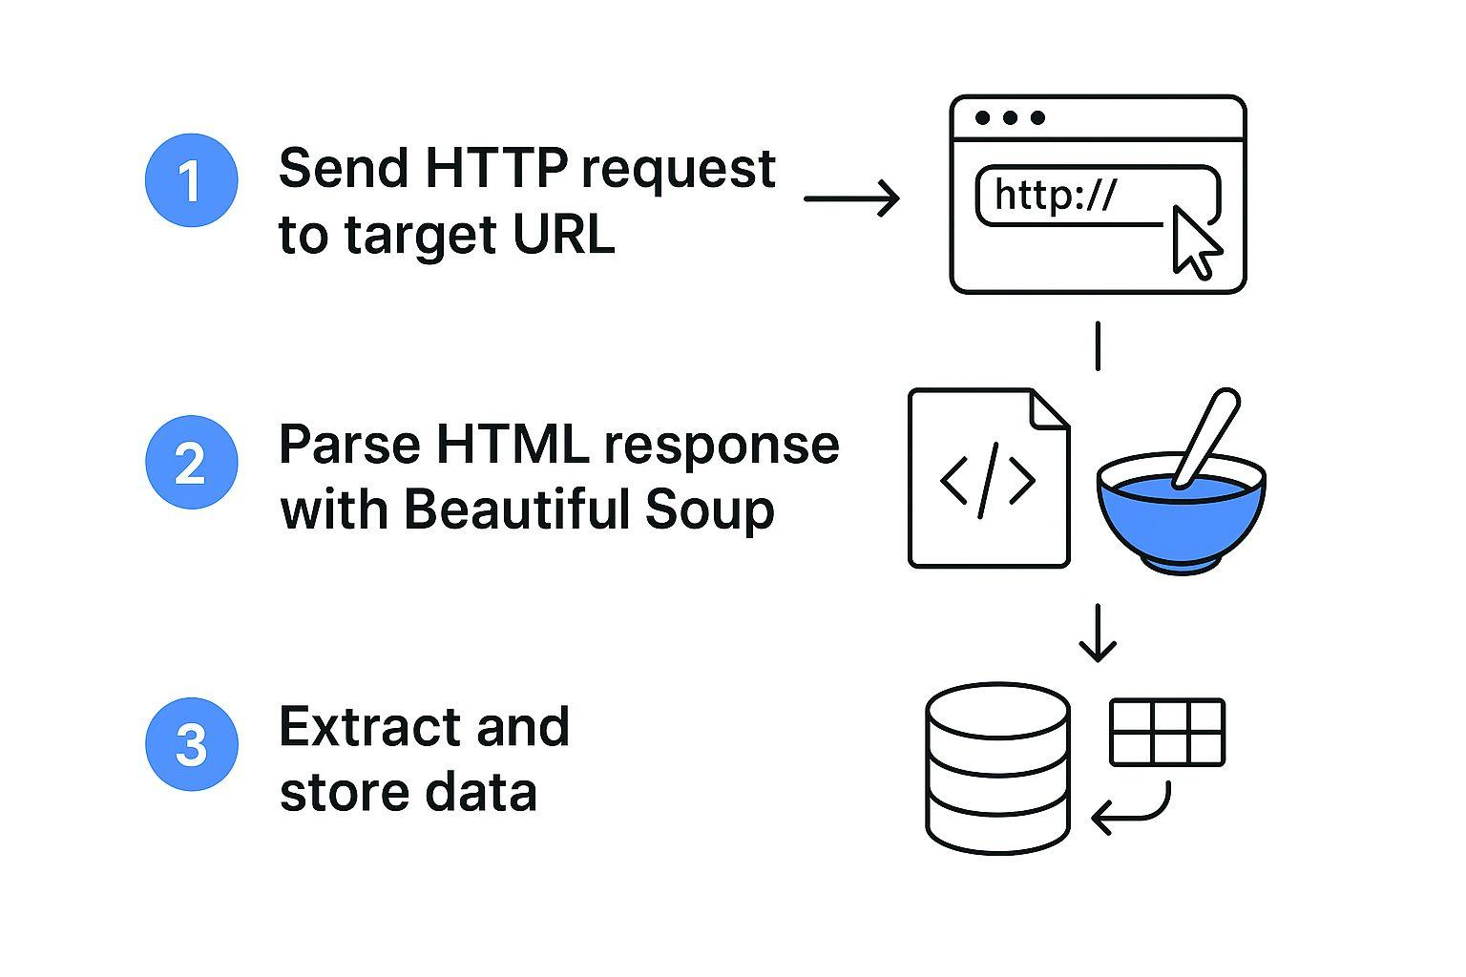
Figure 1: Web Scraping and Data Collection Workflow

Data Extracted
The final analytical dataset contains the following fields:
Column | Description | Data Type
Company Name | Name of the company | Text
Raw Card Text | Original text extracted from the company card | Text
Company Rating | Employee rating of the company | Numeric
Reviews | Number of employee reviews | Numeric
Industry | Industry or business sector of the company | Text
Location | Company location information | Text
Regex-Based Data Extraction
Regular Expressions were used to extract important information from the raw company card text.
Company ratings were extracted from the rating pattern present in the company card. Review counts were extracted using Regex and converted into numeric values.
Review values containing units such as K, L, and M were converted into their corresponding numeric values to make the data suitable for analysis.
Industry and location information were extracted from the structured company card text.
Data Cleaning
The raw dataset was cleaned and prepared for analysis using Python.
The cleaning process included:
- Identifying and removing duplicate company records.
- Converting Company Rating into a numeric data type.
- Extracting review counts using Regex.
- Converting K, L, and M review units into numeric values.
- Removing records without valid Company Rating or Reviews where required for the main analysis.
- Handling missing Industry and Location values.
- Standardizing text fields by removing unnecessary spaces and formatting inconsistencies.
- Excluding Company Size because usable company-size information was not consistently available in the scraped company cards.
- Validating the final dataset for duplicates, missing values, and appropriate data types.
- Keeping the original raw dataset separately from the cleaned dataset.
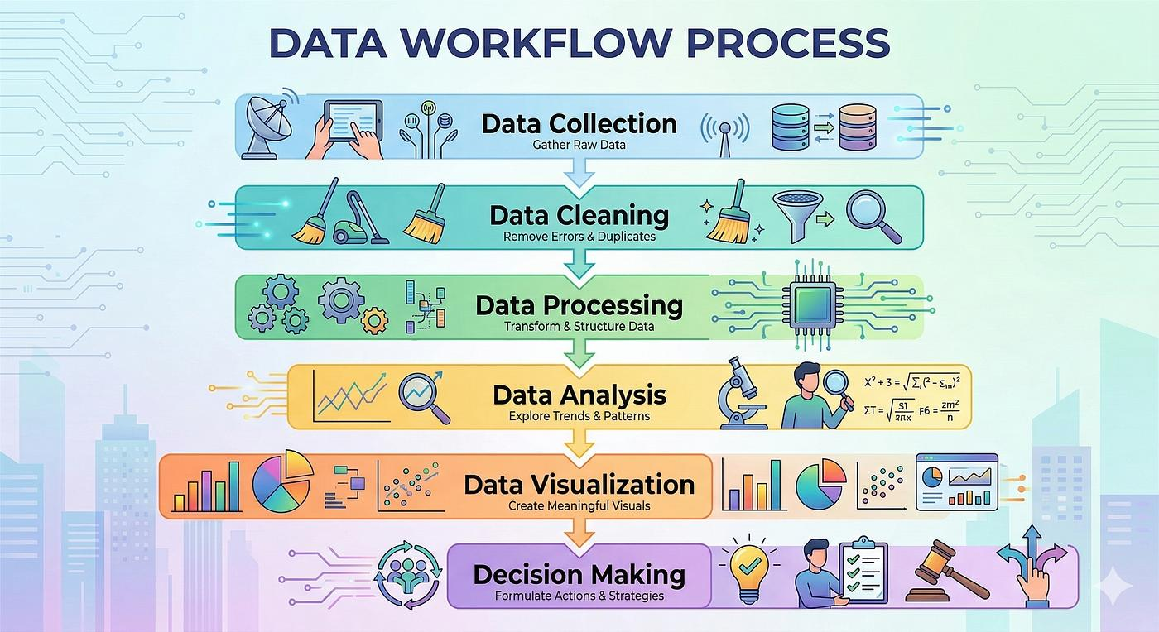
Figure 2: Data Cleaning and Analytics Workflow
Final Dataset
After the data cleaning and validation process, the final analytical dataset contains 495 company records and 6 columns.
The final dataset was checked for duplicate company records and missing analytical values and was prepared for Exploratory Data Analysis and visualization.
Exploratory Data Analysis
The EDA focused on understanding company ratings, review volumes, industries, and locations.
The following analyses were performed:
- Overall dataset overview.
- Top 10 companies by rating.
- Top 10 companies by review count.
- Review statistics.
- Industry distribution.
- Location distribution.
- Average rating by industry.
- Average rating by location.
- Relationship between company ratings and review counts.
Data Visualizations
The project includes the following visualizations:
- Company Rating Distribution
- Top 10 Companies by Rating
- Top 10 Companies by Reviews
- Rating vs Reviews
- Top 10 Industries by Company Count
- Industry Average Rating
- Top 10 Company Locations
- Location Average Rating
These visualizations help identify patterns, rankings, distributions, and relationships within the dataset.
Excel Dashboard
An Excel-based Company Intelligence Dashboard was created to present the major findings in a clear and business-friendly format.
The dashboard title is:
AmbitionBox Top 500 Companies — Company Intelligence Dashboard
The dashboard contains four KPI cards:
- Total Companies: 495
- Average Rating: 3.78
- Total Reviews: 6,629,388
- Average Reviews: 13,393
The dashboard also includes:
- Top 10 Companies by Rating
- Top 10 Companies by Reviews
- Top 10 Industries by Company Count
- Top 10 Company Locations by Count
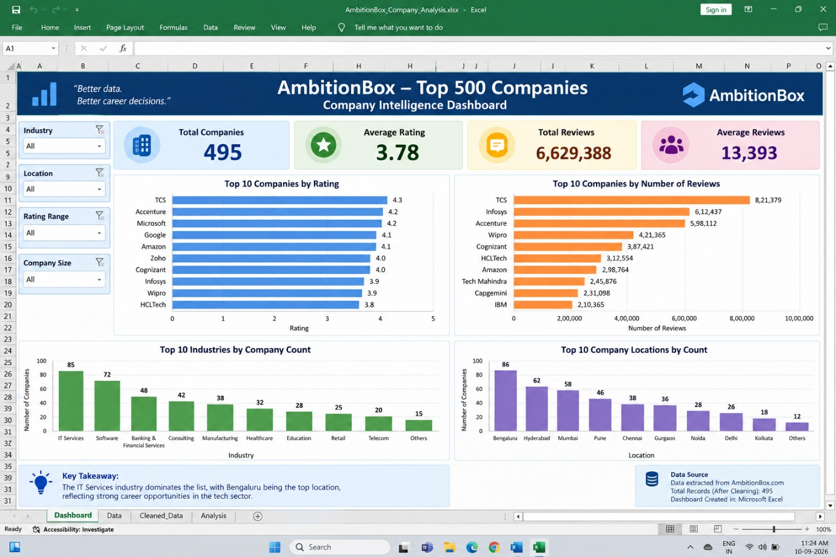
Key Business Insights
The analysis provides several useful business insights.
- Company ratings provide an indication of employee perception of organizations.
- Review volume indicates the level of employee feedback available for each company.
- Industry analysis shows which sectors are strongly represented among the analyzed companies.
- Location analysis highlights the geographical concentration of companies.
- Comparing ratings with review counts helps understand the relationship between employee feedback volume and company ratings.
- Industry-level rating comparisons help identify industries with relatively stronger employee ratings.
- Location-level analysis helps identify geographical areas with higher representation and differences in average ratings.
Business Recommendations
Based on the analysis, the following recommendations can be considered:
- Companies should regularly monitor employee ratings and feedback.
- Organizations with lower ratings should investigate employee concerns and identify improvement areas.
- Employee reviews can be analyzed to better understand workplace expectations.
- Companies should benchmark their ratings against organizations within the same industry.
- Location-level comparisons can help organizations identify regional differences in employee perceptions.
- Regular analysis of employee feedback can support better workplace policies and employee engagement strategies.
Project Deliverables
The project includes the following deliverables:
- Python Web Scraping and Analysis Notebook
- Raw Scraped Dataset
- Cleaned and Structured Dataset
- Data Visualizations
- Excel Company Intelligence Dashboard
- Data Dictionary
- Data Cleaning Documentation
- Business Insights and Recommendations
- Project Report
Project Workflow
Website Selection → Data Collection → Data Understanding → Regex Extraction → Data Cleaning → Exploratory Data Analysis → Data Visualization → Dashboard → Business Insights → Recommendations
Project Outcome
This project demonstrates how raw information collected from a website can be transformed into a structured analytical dataset and used to generate meaningful business insights.
The complete workflow combines web scraping, Regex extraction, data cleaning, exploratory analysis, visualization, and dashboard development.
The final output provides a structured view of AmbitionBox companies based on ratings, reviews, industries, and locations.
Conclusion
The AmbitionBox Top 500 Companies project successfully demonstrates an end-to-end data analytics workflow.
Company information was collected through web scraping, important fields were extracted using Regex, the data was cleaned and validated using Python, and Exploratory Data Analysis was performed to identify meaningful patterns.
Visualizations and an Excel dashboard were developed to communicate the findings effectively.
Overall, the project demonstrates how web-scraped data can be transformed into structured information and used to support business analysis and decision-making.

